**Project description**

**Title: Investigating divergence of *WUSCHEL* and *BABY BOOM* within plant species and maize inbred lines**

**Section I. Personnel**

*Name*: Minjeong Kang   
*Affiliation*: Interdepartmental Plant Biology, Iowa State University, Ames, IA

**Section II. Project**

**1. Background**

**1a. Genes related plant cell morphogenesis**

The cell fate during cell development is specified by various genes and its regulation. The WUSCHEL-RELATED HOMEOBX (WOX) gene family is the well-known example that controls stem cells in plants (*1*). This WOX family plays important role in the developmental process such as determination of cell fate and cell differentiation (*2*). One of the members of WOX family, the *WUSCHEL* (WUS) gene involves in shoot apical meristem (SAM) homeostasis in *Arabidopsis*, and regulates the balance of cell division and differentiation through CLV-WUS feedback system (*3*). *BABY BOOM* (BBM) is one of the AP2/ERF family of transcription factor and specifies basal fate separation during embryogenesis (*4*, *5*).

**1b. Various regeneration capacity of the plant under the tissue culture environment**

The regeneration ability of plant under the tissue culture environment is various upon species and cultivar within the species. For example, although successful maize genetic transformation method has been developed, only few transformable lines were reported. Even if transient transformed plant cell is reported, not all of them is able to obtain regenerated plants. Recently, Lowe et al*.*(2016) reported overexpression of WUS2 and BBM significantly improved regeneration capacity in recalcitrant or marginally transformable maize, rice, sorghum, and sugarcane. Therefore, I assume that investigating the divergence of WUS and BBM in plant species is helpful to understand various regeneration capacity.

**2. Research objectives**

My central hypothesis is that the WUS and BBM genes involve in plant regeneration capacity under the tissue culture environment and their divergence pattern may be related to the various regeneration response. Based on the hypothesis, I have two specific aims: **1)** Investigate the divergence of WUS and BBM in plant and **2)** Investigate the divergence of WUS and BBM in maize inbred lines

**3. Project description**

**3a. Methods**

1) Identification and phylogenetic analysis of WUS and BBM  
 The WUS and BBM sequence from various species will be obtained from NCBI (https://ww w.ncbi.nlm.nih.gov/gene) and EbsemblPlants (http://plants.ensembl.org). Protein sequences for the genes from *Arabidopsis thaliana, Oryza sativa Japonica, Oryza sativa Indica, Zea mays, Sorghum bicolor, Triticum aestivum, Hordeum vulgare, Brassica napus, Glycine max, Gossypium raimondii, Solanum lycopersicum, Solanum tuverosum* and *Dioscorea rotundata* will be aligned by MAFFT. An unrooted tree will be obtained by RAxML with automatically determined protein model.

2) Comparison between phylogenetic analysis of WUS and BBM in selected maize inbred lines and lineage of proprietary dent corn  
 The WUS and BBM sequence from maize inbred lines will be obtained from genotypic data sets in Panzea (https://www.pangea.org). The inbred lines described in the lineage of proprietary dent corn (Version 042011, https://www.maizelineage.com) will be selected for alignment. The DNA sequence will be aligned by MAFFT and a phylogenetic tree will be generated by RAxML based on GTR model. The lineage of proprietary dent corn (Figure 1.) shows the abridged relationship among maize inbred lines based on US PVP, patent and journal publications. Using this lineage, I expect that the comparison will enhance the reliability of estimated phylogenetic tree.

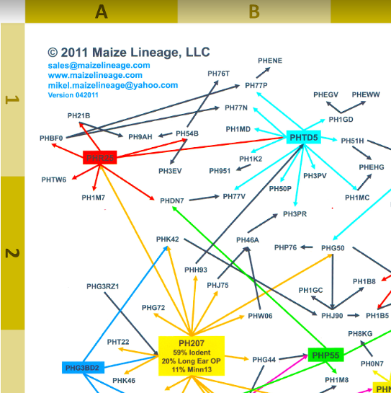

**Figure 1.** Linage of Proprietary Dent corn

**Section III. References**

1. J. M. Alvarez *et al.*, Analysis of the WUSCHEL-RELATED HOMEOBOX gene family in Pinus pinaster: New insights into the gene family evolution. *Plant Physiol. Biochem.* **123**, 304–318 (2018).

2. H. Schoof *et al.*, The Stem Cell Population of Arabidopsis Shoot Meristems Is Maintained by a Regulatory Loop between the CLAVATA and WUSCHEL Genes. *Cell*. **100**, 635–644 (2000).

3. C. C. Carles, J. C. Fletcher, Shoot apical meristem maintenance: the art of a dynamic balance. *Trends Plant Sci.* **8**, 394–401 (2003).

4. C. A. ten Hove, K.-J. Lu, D. Weijers, Building a plant: cell fate specification in the early Arabidopsis embryo. *Development*. **142**, 420–30 (2015).

5. K. Boutilier *et al.*, Ectopic Expression of BABY BOOM Triggers a Conversion from Vegitative to Embryonic Growth. *Plant Cell*, **14**, 1737-1749 (2002).

6. K. Lowe *et al.*, Morphogenic Regulators *Baby boom* and *Wuschel* Improve Monocot Transformation. *Plant Cell*. **28**, 1998–2015 (2016).